**Prelab Questions:**

1. What is longest common subsequence (LCS) problem?
2. What is the LCS for the strings given below?

s1= abbcdbbacbcd

    s2=cabcd

1. Analyze the time complexity of LCS problem
2. What is Travelling Sales person problem? Solve the following TSP problem for the given graph

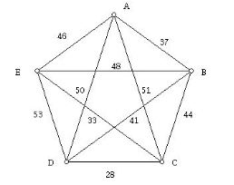

1. Write the Algorithm for TSP and analyze its complexity.

**Prelab Programs:**

1. Implement the TSP problem using dynamic programming.
2. Implement the LCS problem using dynamic programming.